

LEARNER GUIDE
MONITOR AND EVALUATE TEAM MEMBERS AGAINST PERFORMANCE

UNIT STANDARD 252034
NQF LEVEL: 5
CREDITS: 8
NOTIONAL HOURS: 80

LEARNER INFORMATION
Name
Surname
ID Number
Contact

Table of Contents
HOW TO USE THIS GUIDE 3
ICONS 3
PROGRAMME OVERVIEW 4
PURPOSE 4
LEARNING ASSUMPTIONS 4
HOW YOU WILL LEARN 4
HOW YOU WILL BE ASSESSED 4
FORMATIVE ASSESSMENT 4
SUMMATIVE ASSESSMENT 5
SECTION 1: FORMULATION OF PERFORMANCE STANDARDS AND MONITORING SYSTEMS 8
1.1 INTRODUCTION 9
1.2 STEPS IN DEVELOPING PERFORMANCE STANDARDS 12
SECTION 2: PREPARE FOR A PERFORMANCE REVIEW MEETING 28
2.2 COMMUNICATING DETAILS OF THE PERFORMANC REVIEW WITH THE TEAM MEMBER 31
2.3 PRELIMINARY ASSESSMENT OF PERFORMANCE 31
2.4 RECORDING INFORMATION GATHERED DURING PRELIMINARY ASSESSMENTS 33
2.5 EMPLOYEE SELF PREPARATION 35
2.6 DECIDING ON METHODS OF GIVING FEEDBACK 38
2.7 DOCUMENTS FOR PERFORMANCE REVIEW INTERVIEWS 41
SECTION 3: CONDUCTING A PERFORMANCE REVIEW INTERVIEW 49
3.1 INTRODUCTION 50
3.2 CONDUCTING THE INTERVIEW 50
3.3 DEVELOPING AN ACTION PLAN 52

HOW TO USE THIS GUIDE

This workbook belongs to you. It is designed to serve as a guide for the duration of your training programme and as a resource for after the time. It contains readings, activities, and application aids that will assist you in developing the knowledge and skills stipulated in the specific outcomes and assessment criteria. Follow along in the guide as the facilitator takes you through the material, and feel free to make notes and diagrams that will help you to clarify or retain information. Jot down things that work well or ideas that come from the group. Also, note any points you would like to explore further. Participate actively in the skill practice activities, as they will give you an opportunity to gain insights from other people’s experiences and to practice the skills. Do not forget to share your own experiences so that others can learn from you too.

ICONS

For ease of reference, an icon will indicate different activities. The following icons indicate different activities in the manual.


Outcomes
Learning Activities









Stop and Think!
Take note
Note!
Assessment Criteria
Course Material
Notes (Blank)
Reflection
References
Definition
Summaries

Example

PROGRAMME OVERVIEW

PURPOSE

This Unit Standard is intended for managers in all economic sectors. These managers would typically be second level managers such as heads of department, section heads or divisional heads, who may have more than one team reporting to them.

LEARNING ASSUMPTIONS

It is assumed that learners are competent in;
- Communication at NQF Level 4.
- Mathematical Literacy at NQF Level 4.
- Computer Literacy at NQF Level 4.

HOW YOU WILL LEARN

The programme methodology includes facilitator presentations, readings, individual activities, group discussions, and skill application exercises.

HOW YOU WILL BE ASSESSED

This programme has been aligned to registered unit standards. You will be assessed against the outcomes of the unit standards by completing a knowledge assignment that covers the essential embedded knowledge stipulated in the unit standards. When you are assessed as competent against the unit standards, you will receive a certificate of competence and be awarded 8 credits towards a National Qualification.

FORMATIVE ASSESSMENT
In each Learner Guide, several activities are spaced within the content to assist you in understanding the material through application. Activities in the learner manual are not for assessments. Formative assessments are in a separate module written formative assessment. Please make sure that you complete ALL activities in the Formative Assessment Guide, Formative activities must be completed at the end of each section.

SUMMATIVE ASSESSMENT

You will be required to complete a Portfolio of Evidence for summative assessment purposes. A portfolio is a collection of different types of evidence relating to the work being assessed. It can include a variety of work samples.

The Portfolio Guide will assist you in identifying the portfolio and evidence requirements for final assessment purposes. You will be required to complete Portfolio activities on your own time, using real life projects in your workplace environment in preparing evidence towards your portfolio.
Being Declared Competent Entails:
Competence is the ability to perform whole work roles, to the standards expected in employment, in a real working environment.
There are three levels of competence:
- Foundational competence: an understanding of what you do and why.
- Practical competence: the ability to perform a set of tasks in an authentic context.
- Reflexive competence: the ability to adapt to changed circumstances appropriately and responsibly, and to explain the reason behind the action.
To receive a certificate of competence and be awarded credits, you are required to provide evidence of your competence by compiling a portfolio of evidence, which will be assessed by a Services SETA accredited assessor.
You Have to Submit a Portfolio of Evidence
A portfolio of evidence is a structured collection of evidence that reflects your efforts, progress and achievement in a specific learning area, and demonstrates your competence.
The Assessment of Your Competence
Assessment of competence is a process of making judgments about an individual's competence through matching evidence collected to the appropriate national standards. The evidence in your portfolio should closely reflect the outcomes and assessment criteria of the unit standards of the learning programme for which you are being assessed.
To determine a candidate’s knowledge and ability to apply the skills before and during the learning programme, formative assessments are done to determine the learner’s progress towards full competence. This normally guides the learner towards a successful summative (final) assessment to which both the assessor and the candidate only agree when they both feel the candidate is ready.
Should it happen that a candidate is deemed not yet competent upon a summative assessment, that candidate will be allowed to be re-assessed. The candidate can, however, only be allowed two reassessments.
When learners have to undergo re-assessment, the following conditions will apply:
Specific feedback will be given so that candidates can concentrate on only those areas in which they were assessed as not yet competent.
Re-assessment will take place in the same situation or context and under the same conditions as the original assessment.
Only the specific outcomes that were not achieved will be re-assessed.
Candidates who are repeatedly unsuccessful will be given guidance on other possible and more suitable learning avenues.
In order for your assessor to assess your competence, your portfolio should provide evidence of both your knowledge and skills, and of how you applied your knowledge and skills in a variety of contexts.
This Candidate’s Assessment Portfolio directs you in the activities that need to be completed so that your competence can be assessed and so that you can be awarded the credits attached to the programme.

NOTE YOUR POE GUIDE HAS MORE INFORMATION ON THE ASSESSMENT PROCESS

Assessment Process Flow
Assessment Plan agreed by candidate & completed by the assessor before the actual assessment
Knowledge Questionnaire conducted as per the Assessment Plan
Observation conducted as per the Assessment Plan
Portfolio of Evidence compiled as per the Assessment Plan

A detailed Assessor Report compiled & forwarded for Moderation
Record of Learning Updated
Appeal form completed by the candidate in the event of dispute
Feedback Report Completed by Assessor & individual feedback given to the candidate
Assessment Results Moderated
Action Plan Completed by Assessor
All records & evidence filed
Completed Assessor Report / Moderator Report / Record of Learning
Approval & Certification obtained
Certificate of Competencies issued to successful candidates
Register candidates on the Learner Record Database
Portfolio of Evidence submitted to service provider as per the Assessment Plan

CAND
I
DATE
ASSESSMENT
SETA

SECTION 1: FORMULATION OF PERFORMANCE STANDARDS AND MONITORING SYSTEMS

Specific Outcome

On completion of this section you will be able to
- Formulate performance standards for team members in a unit. (SO 1)
- Establish systems for monitoring performance. (SO 2)

Assessment Criteria

- Performance standards to be achieved by team members are formulated in relation to the unit's goals, objectives and deliverables. (SO 1, AC 1)
- Performance standards are clear and concise and specify the activities to be performed and the standards to which they are to be performed. (SO 1, AC 2)
- Feedback from team members is incorporated into the performance standards to promote the buy-in of team members in a unit. (SO 1, AC 3)
- Performance standards are recorded and documented according to the entity's policies and procedures. (SO 1, AC 4)
- A variety of performance monitoring systems are identified and reviewed for possible use in a unit. (SO 2, AC 1)
- The performance monitoring system selected is in line with the entity's policies and procedures for performance assessment. (SO 2, AC 2)
- The performance monitoring system is communicated to team members to promote buy-in. (SO 2, AC 3)
- The system for monitoring performance against standards is set up in accordance with the entity's policy and procedures. (SO 2, AC 4)

1.1 INTRODUCTION

To accomplish the multiple goals of performance appraisals, most organizations are leaning toward a continuous programme of performance management that is very important to both the professional success of an organization and the personal advancement of its employees. A productive performance management system serves an integral business function — it provides a two-way avenue of communication between a supervisor and an employee. It helps employees to improve performance and it helps an organization to succeed in a competitive, cost-conscious environment.

Contrary to what some supervisors believe, the annual performance appraisal is not an end in itself — it is a means to an end. It is only one part, the third and final part goes to, ongoing performance management process that is preceded by performance planning (i.e. setting reasonable performance expectations and standards) and coaching and counselling (i.e., providing constructive feedback, guidance and assistance for the purpose of improving employee performance).

Supervisors and managers are employed to manage the performance (effectiveness and efficiency) of an organization (business, service agency, etc.) and the people (employees, staff, etc.) who make up the human resources of the organization. Unfortunately, much of the research conducted in most organisations indicates they are not doing a very good job of it.

For example:
    - 70% say managers do not provide clear goals and directions
    - 55% say their managers are poor or average in providing direction
    - 70% say performance expectations are not clearly defined
    - 70% have never had meaningful performance discussion with their manager
    - 65% say the most important information needed concerns ways to improve performance
    - 80% say their supervisor does not follow up on the review
    - 71% of professionals believe their company’s system for evaluating performance is not fair
    - 52% say poor performance is tolerated too long
    - 80% do not see a relationship between good work and rewards
    - 98%believe pay should reflect performance and only 48% believe their company’s pay system does
    - 70% want more recognition of their efforts
    - 70% of professionals believe their pay is not tied to performance.

To be effective at evaluating an employee’s performance, it is necessary for a supervisor to understand the entire performance management and appraisal process.

Definition of Performance Management
According to Armstrong and Baron (1998), Performance Management is both a strategic and an integrated approach to delivering successful results in organizations by improving the performance and developing the capabilities of teams and individuals. The term performance management gained its popularity in early 1980’s when total quality management programs received utmost importance for achievement of superior standards and quality performance.

Tools such as job design, leadership development, training and reward system received an equal impetus along with the traditional performance appraisal process in the new comprehensive and a much wider framework. Performance management is an ongoing communication process which is carried between the supervisors and the employees throughout the year.

Components of a Performance Management System
Effective performance management system includes the following components:
- Performance Planning: Performance planning is the first crucial component of any performance management process which forms the basis of performance appraisals. Performance planning is jointly done by the appraisee and also the reviewee in the beginning of a performance session. During this period, the employees decide upon the targets and the key performance areas which can be performed over a year within the performance budget which is finalized after a mutual agreement between the reporting officer and the employee.

- Performance Appraisal and Reviewing: The appraisals are normally performed twice in a year in an organization in the form of mid reviews and annual reviews which is held in the end of the financial year. In this process, the appraisee first offers the self filled up ratings in the self appraisal form and also describes his/her achievements over a period of time in quantifiable terms. After the self appraisal, the final ratings are provided by the appraiser for the quantifiable and measurable achievements of the employee being appraised. The entire process of review seeks an active participation of both the employee and the appraiser for analyzing the causes of loopholes in the performance and how it can be overcome. This has been discussed in the performance feedback section.

- Feedback on the Performance followed by personal counselling and performance facilitation: Feedback and counselling is given a lot of importance in the performance management process. This is the stage in which the employee acquires awareness from the appraiser about the areas of improvements and also information on whether the employee is contributing the expected levels of performance or not. The employee receives an open and a very transparent feedback and along with this the training and development needs of the employee is also identified. The appraiser adopts all the possible steps to ensure that the employee meets the expected outcomes for an organization through effective personal counselling and guidance, mentoring and representing the employee in training programmes which develop the competencies and improve the overall productivity.

- Rewarding good performance: This is a very vital component as it will determine the work motivation of an employee. During this stage, an employee is publicly recognized for good performance and is rewarded. This stage is very sensitive for an employee as this may have a direct influence on the self esteem and achievement orientation. Any contributions duly recognized by an organization helps an employee in coping up with the failures successfully and satisfies the need for affection.

- Performance Improvement Plans: In this stage, fresh set of goals are established for an employee and new deadline is provided for accomplishing those objectives. The employee is clearly communicated about the areas in which the employee is expected to improve and a stipulated deadline is also assigned within which the employee must show this improvement. This plan is jointly developed by the appraisee and the appraiser and is mutually approved.

- Potential Appraisal: Potential appraisal forms a basis for both lateral and vertical movement of employees. By implementing competency mapping and various assessment techniques, potential appraisal is performed. Potential appraisal provides crucial inputs for succession planning and job rotation.

Benefits of Performance Management

A good performance management system works towards the improvement of the overall organizational performance by managing the performances of teams and individuals for ensuring the achievement of the overall organizational ambitions and goals. An effective performance management system can play a very crucial role in managing the performance in an organization by:
- Ensuring that the employees understand the importance of their contributions to the organizational goals and objectives.
- Ensuring each employee understands what is expected from them and equally ascertaining whether the employees possess the required skills and support for fulfilling such expectations.
- Ensuring proper aligning or linking of objectives and facilitating effective communication throughout the organization.
- Facilitating a cordial and a harmonious relationship between an individual employee and the line manager based on trust and empowerment.

Performance management practices can have a positive influence on the job satisfaction and employee loyalty by:
- Regularly providing open and transparent job feedbacks to the employees.
- Establishing a clear linkage between performance and compensation
- Providing ample learning and development opportunities by representing the employees in leadership development programmes, etc.
- Evaluating performance and distributing incentives and rewards on a fair and equated basis.
- Establishing clear performance objectives by facilitating an open communication and a joint dialogue.
- Recognizing and rewarding good performance in an organization.
- Providing maximum opportunities for career growth.

An effectively implemented performance management system can benefit the organization, managers and employees in several ways as depicted in the table given below:

Organization’s Benefits | Improved organizational performance, employee retention and loyalty, improved productivity, overcoming the barriers to communication, clear accountabilities, and cost advantages.
Manager’s Benefits | Saves time and reduces conflicts, ensures efficiency and consistency in performance.
Employee’s Benefits | Clarifies expectations of the employees, self assessment opportunities clarifies the job accountabilities and contributes to improved performance, clearly defines career paths and promotes job satisfaction.

1.2 STEPS IN DEVELOPING PERFORMANCE STANDARDS
We shall now discuss the eight-step process for developing employee performance standards that support organizational goals.

Step 1: Look at the overall picture
Instead of beginning at the bottom of the organization with the position description to develop employee performance standards, begin the process by looking at your department’s goals and objectives. Gather information relating to your department’s general outcome goals as outlined in its departmental plan.

Step 2: Determine the accomplishments at the work unit level.
The next step is to determine the accomplishments (i.e., the products or services) of the work unit. Identifying work unit accomplishments lets you identify appropriate measures in the following steps of this process. The goal cascading method can be used for the process of determining unit goals from departmental goals. This method works best for organisations that set clear organizational goals and objectives, such as those established in the strategic plans and annual performance plans.

Below is an example of departmental objective of XY insurance company (claims division). Let’s see how the departmental objectives are transformed into unit objectives.
Example
Departmental goal  Claims department | To enhance customer service standards
Team objective | - Reduce claim processing time to 2 days by end of 30 September.  - To reduce claims errors by 10 % by 30 June  - To handle and solve customer complaints within 24 hours.

Apart from determining the unit objectives, the supervisor must determine;
- The products and services that the unit produces to meet its unit objectives. At this point, it is important to know the customer quality standards for these products and services.
- The process or steps that the unit takes to produce the products and services. This must be presented on a flow chart. The flow chart must show the work process, maps out each successive step, and ends with the final or semi-product or service produced by the unit.

Step 3: Determine individual accomplishments that support work unit goals

The next step is to determine how each individual contributes to the unit goals and objectives.
Elements that address individual accomplishments can be identified using a role-results matrix. A role-results matrix is simply a table that identifies the results each work unit member

To build the matrix,
- List the work unit’s products or services across the top row of a table.
- List each member of the work unit or each job position down the left column of the matrix.
- For each cell of the table, ask this question: What must this unit member produce or perform (i.e., accomplish) in order to support this particular work unit product or service?
- List those employee products or services (i.e., accomplishments) in the appropriate cell. The products or service you list for each unit member are possible performance elements that might be included in the employee’s performance plan.

All performance elements should be either quantifiable or verifiable and should be described as accomplishments (nouns), not activities (verbs). Example of a role matrix is shown on the next page.

Example: role matrix

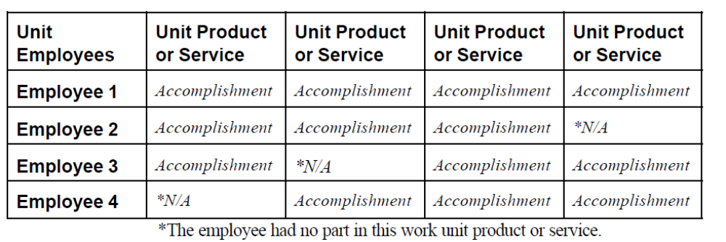

Below is another example for a role matrix for a unit which is responsible for planning, drafting, editing, and adding visuals to news articles.
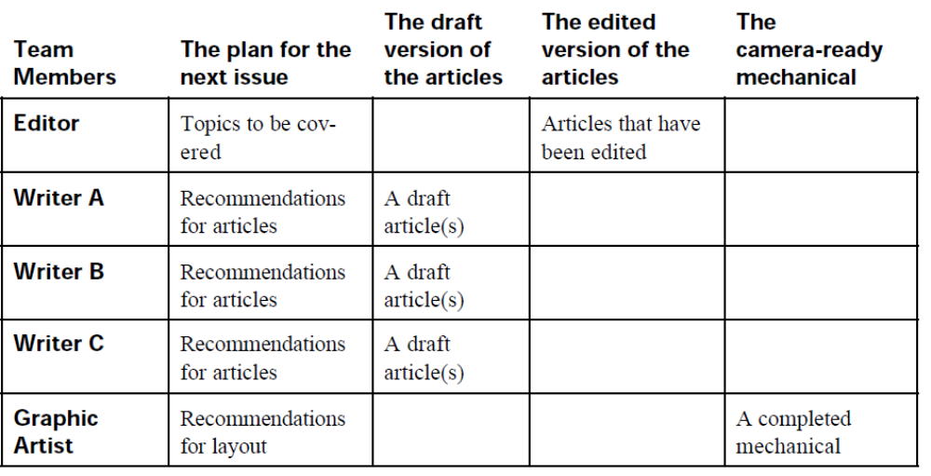

Note: The supervisor must check the job description of each team member during the process of developing a role matrix.

Step 4: Convert expected accomplishments into performance elements, indicating type and priority.
In Steps 2 and 3 of the process presented you developed the expected accomplishments for the work unit and the unit’s employees. Now, in Step 4, you will:
- identify which accomplishment(s) should be included as elements in the performance plan;
- select which type of element to use; and
- Assign weights or priorities.

All employees must have at least one critical element and other non-critical elements in their performance plan. Critical elements must address individual performance only

Once you have classified elements as critical, non-critical, or additional, and if your appraisal program allows, prioritize them so that work units and employees know which elements are most important. One way to do this is to distribute 100 percentage points across the elements based upon each one’s importance to the organization.

NB
To help decide whether an element should be classified as critical or not, answer the following questions:
- Is the element a major component of the work? If you answered “yes,” the element might be critical.
- Does the element address individual performance only? Elements measuring group performance cannot be critical elements, except as explained for supervisors and only under certain circumstances.
- If the employee performed unacceptably on the element, would there be serious consequences to completing the work of the organization? If employee error on the element affects the work unit’s accomplishments, the element may be critical.
- Does the element require a significant amount of the employee’s time? If you answered “yes,” the element might be critical.

Below is an example of how to weigh and determine the critical responsibilities of a receptionist.

Employee assignments or responsibility | Type of element | Priority points
Receive, direct and relay telephone messages and fax messages | Critical (CE) | 40
Pick up and deliver the mail | Critical (CE) | 40
Maintain the general filing system and file all correspondence | Additional (AE) | 10
Maintain an adequate inventory of office supplies | Additional (AE) | 5
Coordinate the repair and maintenance of office equipment | Additional (AE) | 5
Total |  | 100
*Note: The supervisor must verify the employee assignments or responsibility as per the job descriptions Or ask for team or individual input.
Step 5: Determine work unit and individual measures

In Step 4 of this process, you designated the critical, non-critical, and additional performance elements you will include in your performance plan. In Step 5, you will determine how to measure performance of those elements. Measures are the yardsticks used to determine how well work units and employees produced or provided products or services. To develop specific measures of performance for each element in your performance plan, you first must determine the general measures that apply to each. Once you determine the general and specific measures, you will be able to develop the standards for your elements, which you will do in

The four general measures used for measuring work unit and employee performance:

- Quality: Addresses how well the employee or work unit performed the work and/or the accuracy or effectiveness of the final product. Quality refers to accuracy, appearance, usefulness, or effectiveness. Quality measures can include error rates (such as the number or percentage of errors allowable per unit of work) and customer satisfaction rates (determined through a customer survey).
- Quantity: addresses how much work the employee or work unit produced. Quantity measures are expressed as a number of products produced or services provided, or as a general result to achieve.
- Timeliness: addresses how quickly, when, or by what date the employee or work unit produced the work.

NOTE
To develop specific measures, you first must determine the general measure(s) that are important for each element (i.e., quantity, quality, timeliness, or cost-effectiveness). Then, determine how to measure the quantity, quality, timeliness, and/or cost-effectiveness for the element.

If you can measure an accomplishment with numbers, record the form of measurement. If you can only describe performance (i.e., observe and verify), clarify who will appraise the performance and the factors they will appraise.

Priority points | Employee assignments or responsibility | Type of element | General measure | Specific measure
40 | Receive, direct and relay telephone messages and fax messages | Critical (CE) | Timeliness | - Number of rings for incoming calls  - Seconds before transfers are made to the right person
40 | Pick up and deliver the mail | Critical (CE) | Timeliness | - Number of minutes it takes to pick up and deliver mail
10 | Maintain the general filing system and file all correspondence | Additional (AE) | Quality | - Ratio of filing errors
100 | Total

NOTE: Team involvement is required

Step 6: Develop work unit and individual standards.
The next step in the process of developing a performance plan is to establish standards for the elements.

Performance standards are management approved expressions of the performance threshold(s), requirement(s), or expectation(s) that employees must meet to be appraised at particular levels of performance.

What should performance standards include?
Once you have established the specific measures that apply to the elements, you can begin to write the standards. Before writing the Fully Successful standard, you must know the number of levels that your appraisal programme uses to appraise elements. For example, if you are under an appraisal program that uses two levels to appraise elements, the Fully Successful standard would describe a single point of performance.

Any performance at or above that point is Fully Successful and anything below it is Unacceptable. If, however, your appraisal program uses five levels to appraise performance, you would describe the Fully Successful standard as a range. Performance that exceeds the top of that range would be appraised at the level(s) above Fully Successful, and performance below the bottom of that range would be Minimally Successful (or equivalent) or Unacceptable.

NOTE: Team involvement is required

The diagram next page shows an example of how to add performance standards to elements
Priority points | Element type, and priority points | General measure | Specific measure | Minimally successful | Fully successful | Exceeds fully successful
40 | Receive, direct and relay telephone messages and fax messages  Critical element  40 priority points | Timeliness | - Number of rings for incoming calls  - Seconds before transfers are made to the right person | - 4-5 rings before answering incoming calls  - 6-10 seconds transfer lead time | - 3 rings before answering incoming calls  - 5 seconds transfer lead time | - 1-2 rings before answering incoming calls  - 2-4 seconds transfer lead time
40 | Pick up and deliver the mail  Critical element  40 priority points | Timeliness | - Number of minutes it takes to pick up and deliver mail | - 40-60 minutes lead time | - 30 minutes lead time | - 15-25 minutes lead time
10 | Maintain the general filing system and file all correspondence  Additional element  10 priority points | Quality | - Ratio of filing errors | - 12%- 20% | - 5%-10% | - 1%-3%

NOTE:

1. performance measures must be clear and concise
When setting performance standards it is easy to be too concise and to overlook some critical details in how these standards are described.

For example, for a sales person: Meeting sale targets, may seem simple, however do you require a sales person to meet their annual sales target or all 12 monthly targets?

2. Performance standards must be recorded and documented
After completing the process of developing performance standards, they must be recorded in the right format specified by the organisation. After recording them they must be filed and treated as confidential.

Step 7: Determine how to monitor performance.
Monitoring performance means measuring performance and providing feedback to employees. Agency appraisal programs are required to provide ongoing appraisal, which includes, but is not limited to, conducting one or more progress reviews during each appraisal period. In addition to a once- or twice-a-year progress review, which is sometimes a formal part of the appraisal process, supervisors and employees are encouraged to discuss performance informally and often.

Determining how to monitor performance is an important step in developing performance plans.
You may have worked through the previous six steps of the process, developed what you thought were great elements and standards, and then found that monitoring performance on an element is impossible, or too costly, or too time consuming. If this happens, think through other specific measures that indicate performance measures that are as specific as possible.

To complete this step in the process:
- Determine what data to collect for each performance element, the source of the data, and whether to collect all the data or just a sample.
- Determine when to collect the data, who will collect it, and who will receive it.
- Review existing reports for possible use as feedback reports.
- Create feedback tables or graphs where necessary or applicable.
- Try to design feedback processes that give feedback automatically.
NOTE: Team involvement is required when setting up methods of monitoring performance.
Priority points | Element type, and priority points | General measure  EXAMPLES OF FEEDBACK SOURCES | Specific measure | Minimally successful | Fully successful | Exceeds fully successful | Feedback source for monitoring
40 | Receive, direct and relay telephone messages and fax messages  Critical element  40 priority points | Timeliness | - Number of rings for incoming calls  - Seconds before transfers are made to the right person | - 4-5 rings before answering incoming calls  - 6-10 seconds transfer lead time | - 3 rings before answering incoming calls  - 5 seconds transfer lead time | - 1-2 rings before answering incoming calls  - 2-4 seconds transfer lead time | - Supervisor observation-360 degree tool  - Customers  - peers
40 | Pick up and deliver the mail  Critical element  40 priority points | Timeliness | - Number of minutes it takes to pick up and deliver mail | - 40-60 minutes lead time | - 30 minutes lead time | - 15-25 minutes lead time | - Supervisor observation-360 degree tool  - Customers  - peers
10 | Maintain the general filing system and file all correspondence  Additional element  10 priority points | Quality | - Ratio of filing errors | - 12%- 20% | - 5%-10% | - 1%-3% | - Supervisor observation-360 degree tool  - Peers  - Data from automated system

Methods for monitoring employee performance
Monitoring can take several forms, depending upon the nature of the performance that is being appraised. Wherever possible, it makes sense to use existing systems that will not add work steps for either the employee or the supervisor. Some monitoring approaches include:
(1) Reviewing work, either total output or samples.
(2) Observing employee work activities.
(3) Reading reports, charts, time sheets, work records, or logs, etc.
(4) Self-reporting on progress by the employee.
(5) Surveying other units, the public, or clients of the services.
(6) Noting and investigating complaints and commendations.
Some monitoring will be ongoing, designed to detect performance problems in the early stages. This might involve, for example, checking work samples or observing employee activities several times a day or several times a week. Other monitoring may be at more widely spaced intervals, either regular monthly or quarterly reviews, or on an occasional random basis.

360-degree (multi-rater) assessment process

360-degree feedback, also known as 'multi-rater feedback', is employee development feedback that comes from colleagues, peers and managers in the organization, as well as self-assessment, and sometimes sources such as clients, volunteers or other stakeholders.

Senior managers (including executive directors) are responsible for assessing the performance of other employees but often do not receive adequate feedback themselves. 360-degree feedback allows the individual to understand how his or her effectiveness as an employee, manager, or co-worker is viewed by others.

What an effective 360-degree feedback process can achieve:
- Individuals get a broad perspective of how they are perceived by others and how they impact others — both positively and negatively
- Encourages open feedback and this feedback is often perceived as more valid and objective, leading to acceptance of results and actions required
- Clarifies critical performance aspects, reinforces desired competencies and identifies strengths that can be used to the best advantage of the organization
- Supports a climate of continuous improvement and focuses agenda for development, identifying key development areas for the individual, a team or the organization as a whole
- Gaps are identified between employee’s self-perception versus the perception of manager, peers or direct reports
- When feedback comes from a number of individuals in various job functions, discrimination because of race, age, gender, and so on, is reduced. Similarly, the "horns and halo" effect, in which a supervisor rates performance based on his or her most recent interactions with the employee is also reduced

Why organizations may choose not to adopt the 360-degree approach:
- Feedback from multiple assessors increases the number of people participating in the process and the organizational time invested
- Employees are not ready to give or receive honest and open feedback. The process can be intimidating as few people enjoy being evaluated, especially by a circle of colleagues and peers. Some cultures rigidly avoid passing constructive feedback, or information, to superiors or managers
- If a performance management system is tied to pay increase and reward systems, people may be hesitant to participate. There is a big difference between providing feedback that will contribute to professional development or providing feedback that determines pay, rewards, and promotion
- Since feedback is most often provided in written form, not in person to ensure anonymity, people receiving feedback can’t ask directly for clarification of comments or more information about ratings and their basis

Communicating the performance monitoring system
Monitoring performance is not a witch hurting exercise to get rid of your enemies. Therefore, after setting up a performance monitoring system, the supervisor must communicate it to all team members. Communication can be done through;
- Meetings at the start of end of a shift
- Via emails
- Notice boards.
- Formal letter
- During induction and coaching processes.

Step 8: Check the performance plan.

Once you have developed a performance plan using the previous seven steps, checking your work is always a good idea. Use the checklist below to ensure that the elements and standards you developed to include in the performance plan are effective and meet regulatory requirements:

- Are the critical elements truly critical? Does failure on the critical element mean that the employee’s overall performance is unacceptable?
- Is the range of acceptable performance clear? Are the performance expectations quantifiable, observable, and/or verifiable?
- Are the standards attainable? Are expectations reasonable?
- Are the standards challenging? Does the work unit or employee need to exert a reasonable amount of effort to reach the fully successful performance level?
- Are the standards fair? Are they comparable to expectations for other employees in similar positions? Do they allow for some margin of error?
- Are the standards applicable? Can the appraiser( s) use the standards to appraise performance?
- Can the appraiser(s) manage the data collected through the measurement process?
- Will work units and employees understand what is required?
- Are the elements and standards flexible? Can they be adapted readily to changes in resources or objectives?
- If your program permits appraising element at levels above the Fully Successful or equivalent level, is the Fully Successful or equivalent standard surpassable? Is it possible for a work unit’s or an employee’s performance to exceed it?

INVOLVING TEAM MEMBERS IN SETTING PERFORMANCE STANDARDS
The process of setting standards should be established with the participation of those responsible for meeting them. After all, well-selected, trained employees should know more about what is achievable than anyone else.
An effective way for the team to work together to establish performance standards and the action plans to achieve them is by filling the roles as outlined below.

Team Member | Supervisor
Helps establish performance goals and standards. This is a “self-contract” for achievement and a commitment to deliver a result for the team. | Ensures team goals are achievable but challenging enough to meet organizational needs and provide a sense of accomplishment.
Develops methods to measure results and checkpoints for control purposes. | Helps balance the complexity of measures and controls with value received.
Outlines the action required to accomplish goals and standards. | Participates with the team to test the action plan’s validity against alternatives.
Reports progress as work is performed. Seeks guidance and assistance when needed. Adjusts plan as required. | Follows the progress of the work. Reinforces achievement and assists in problem solving when indicated. Ensures targets are met, or modified if circumstances so indicate.

RECORDING AND DOCUMENTING PERFORMANCE STANDARDS

After developing and finalising performance standards, they must be recorded and documented properly. Confidentiality of performance standards must be adhered to in line with organisational policies and procedures.

The next page shows an example of a template that can be used to record performance standards.

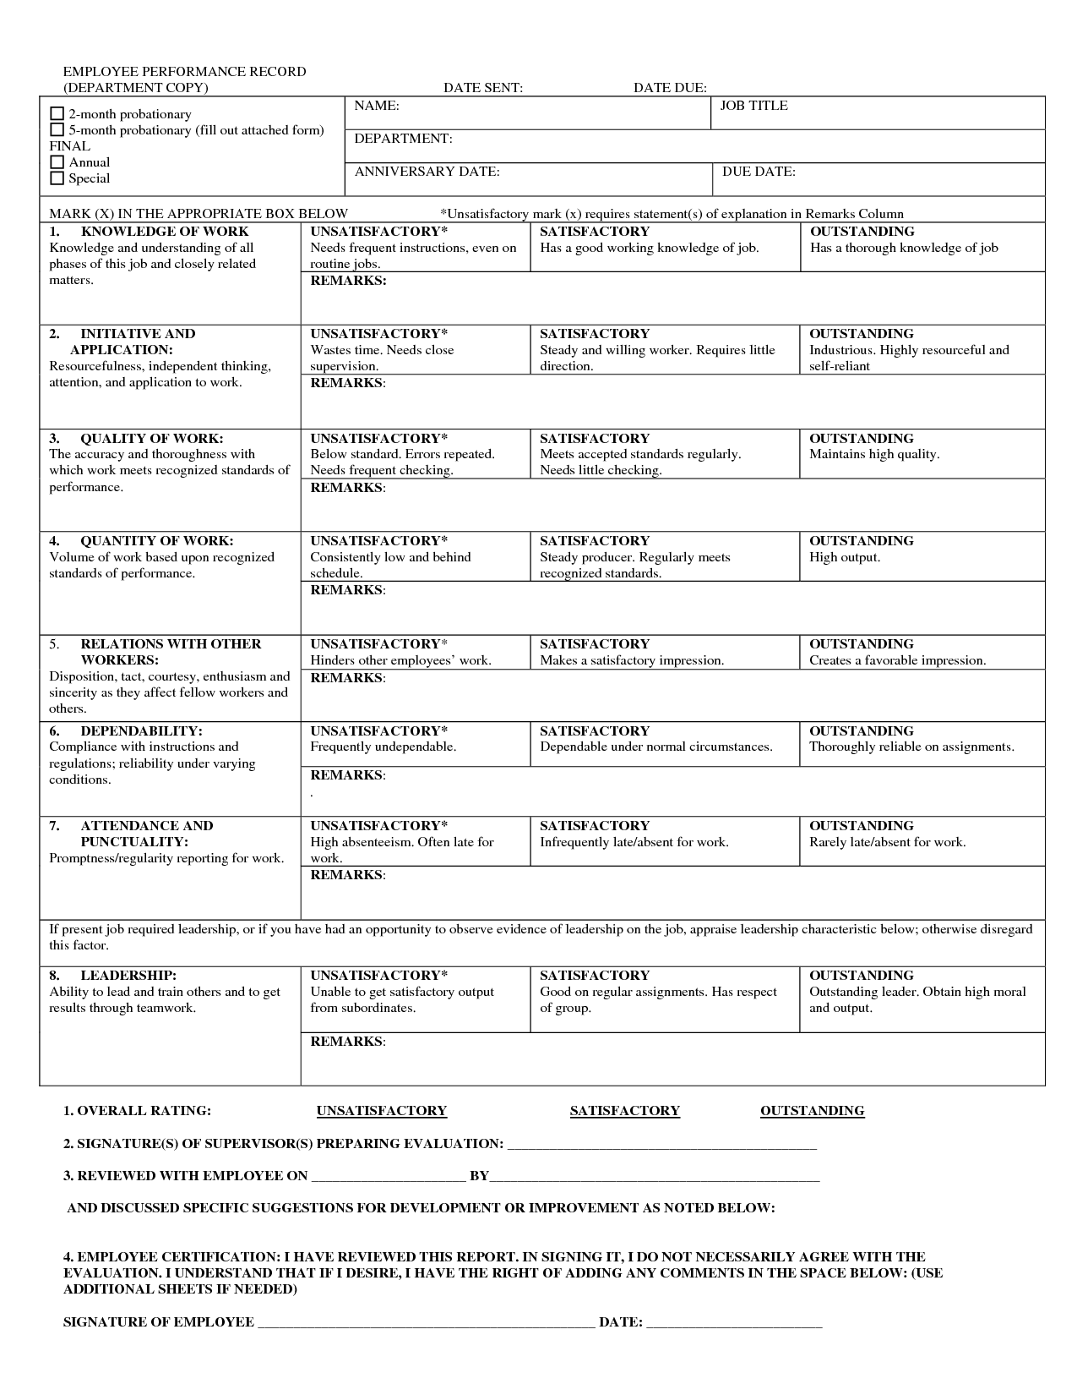
Activity

Using all the steps discussed in this section, develop performance standards for any one team member of your choice. Follow the 8 steps discussed in this section.

SECTION 2: PREPARE FOR A PERFORMANCE REVIEW MEETING

Specific Outcome

On completion of this section you will be able to prepare for a performance review of a team member.

Assessment Criteria

- The arrangements for the performance review are agreed with team member, including the time, place and nature of the review. (SO 3, AC 1)
- Information gathered during the preliminary assessment is documented to be available for future reference. (SO 3, AC 3)
- Methods for giving constructive feedback are identified that make provision for reporting positive and negative findings. (SO 3, AC 4)
- Documents to be used during the review are prepared in accordance with the entity's policies and procedures. . (SO 3, AC 4)
- Feedback provided to the team member is relevant and fair and communicated in a constructive and supportive manner. (SO 4, AC 2)

2.1 INTRODUCTION

The performance appraisal interview is the first round in the performance appraisal process and this is the round in which the manager communicates his evaluation of the employee’s performance during the appraisal period or the time that the employee’s performance is being evaluated.

2.1.1 Definition of a Performance Appraisal Interview
A performance appraisal interview is the first stage of the performance appraisal process and involves the employee and his or her manager sitting face to face to discuss threadbare all aspects of the employee’s performance and thrash out any differences in perception or evaluation. The performance appraisal interview provides the employee with a chance to defend himself or herself against poor evaluation by the manager and also gives the manager a chance to explain what he or she thinks about the employee’s performance

In a nutshell, the performance appraisal interview precedes the normalization process and is subsequent to the employee filling up the evaluation form and the manager likewise doing so. The interview is the stage where both sides debate and argue the employees’ side of the story as well as the manager’s perception.

2.1.2 Appraise and Appraiser
- The employee who is being evaluated is called the appraise and the person (usually the manager) who is doing the evaluation is called the appraiser.
- The appraiser and appraise prepare themselves for this round by doing a self evaluation (by the appraise) and an objective evaluation (by the appraiser).
- This is the round in which the most important achievements as well as glaring failures on the part of the appraise are discussed threadbare and usually the employee’s role in the process is limited to this round.

2.1.3 The outcome of a performance appraisal
The outcome of the appraisal process is the grade that is decided for the employee as well as the salary hike or the bonus potential that is awarded to the employee. Typically, organizations divide the year in which the employee’s performance is evaluated into two cycles, one for deciding the salary hike and the other for deciding how much bonus he or she gets for the cycle. In this way, organizations ensure that there is no overlap in grading the employee and a fair and balanced evaluation is the desired outcome though this does not always happen in reality.

NOTE
The Performance Appraisal Interview consists of the following three Stages:
1. Preparing for the Appraisal
2. Conducting the Appraisal
3. Following Up

2.2 COMMUNICATING DETAILS OF THE PERFORMANC REVIEW WITH THE TEAM MEMBER

Always give your employee fair warning of when their performance appraisal interviews are to take place. They should have at least a week’s notice to review their work.

When you notify your employees of the date for their appraisal, stress that the appraisal is designed mainly to help them understand their own performance in the company. Work out a mutually agreeable time for the interview. Plan it for a day when your relationship with your employee is at its best. Be sure to allow enough time in your schedule for the entire interview (of course, warn your employees to do the same.)

EXPLAIN THOROUGHLY TO THE EMPLOYEE HOW THE ACTUAL EXERCISE WILL BE CONDUCTED

Your aim is to relax your employee. As you tell the employee how the interview will proceed and what you hope to accomplish, define the roles each of you will play. Make it clear that you are having a two-way conversation. Emphasise that the employee has your undivided attention and that you have blocked out an extended time period for the appraisal.

2.3 PRELIMINARY ASSESSMENT OF PERFORMANCE
As part of preparation of a performance review interview, the supervisor must conduct a preliminary assessment of the performance of the employee against agreed standards. The following are the steps in conducting the preliminary assessment
- Collect all the information you need for the interview.
- Review the relevant job description.
- Compare the employee’s performance against these criteria.
- Look back in the files at the employee’s previous performance appraisal (if one exists). Ask yourself whether the employee has met the goals set. Be careful not to let these past evaluations influence your impression of the employee’s current performance.
- Request comments from other managers who have observed the employee’s work.
- Complete the appraisal form. It will enable you to conduct an organised interview.

Be warned against developing an improvement plan at this point. Hold that for the interview itself and leave the primary responsibility to the employee.

OBSERVE – OBSERVE – OBSERVE

- Job descriptions are a general statement of the job duties and responsibilities.
- Weed out the important job duties from the unimportant.
- Be sure your observation is balanced and fair.
- Performance raters can easily go wrong if they rely on incidents that are either too old or too new or if they base their judgement on a typical work period.
Ultimately it is the performance that counts.
- Appraise only if you have enough information.
- Always keep the appraisal’s purpose in mind.
- List employee’s strengths and weaknesses. Make your comments as specific and wide-ranging as possible.
- When you dislike aspects of an employee’s personality, assess job performance, not personality.
- When you have mixed feelings about an employee’s work, your doubts can affect you ability to conduct an effective performance appraisal. When this happens, turn to the facts and let them guide your opinion.
- Aim for accuracy.

2.4 RECORDING INFORMATION GATHERED DURING PRELIMINARY ASSESSMENTS

It is important for the supervisor to record all findings made during the preliminary assessments. The recorded information can be useful during the actual performance review meeting and for future reference. The following template can be used to capture information collected during preliminary assessments. The document differs from organisation to another.

PERFORMANCE EVALUATION PRELIMINARY WORKSHEET

EMPLOYEE:

POSITION:

SUPERVISOR:

Performance review is scheduled for:

This worksheet is designed to provide an opportunity for staff members and their supervisors to document employee strengths and areas for improvement. Please complete this form independently prior to your scheduled performance review. Performance evaluations may include, but are not limited to, the items indicated on this worksheet.

JOB DESCRIPTION PRESENTLY ON FILE:

CHANGES IN JOB DESCRIPTION:
List all duties that have been added to or removed from the job description as printed above. Include rationale for specific change.

PROFESSIONAL GOALS:
- Review of previous goals:

- New/continued goals: EMPLOYEE STRENGTHS:

- EMPLOYEE AREAS FOR IMPROVEMENT:

- ORGANISATION’S STRENGTHS (as they affect this position):

- AREAS FOR IMPROVEMENT FOR THE ORGANISATION (as they affect this position):

- WAYS IN WHICH SUPERVISOR OR ORGANISATION MIGHT ASSIST EMPLOYEE IN IMPROVING JOB PERFORMANCE:

2.5 EMPLOYEE SELF PREPARATION
The employee must be given a chance to prepare himself for the performance review interview. Some of the questions that an employee must ask himself include;
- How well do you think you have done in achieving your objectives?
- How well have any improvement, development or training plans as agreed with you, been put into place?
- What objectives relating to your key tasks would you like to agree with your Manager?
- Have you met with any problems in carrying out your work? If so, what sort of problems and what can be done about them?
- Do you think your manager could provide you with more guidance or help in what he or she expects you to do? If so, what guidance or help do you need?
- Do you think the best use is being made of your skills and abilities? If not, what can be done about it?
- Do you feel you are ready to take on additional responsibilities in your present job? If so, what would you like to do?
- Would you like to gain experience in other related areas of work? If so, what would you like to do?
- What direction would you like your future career to take with the organization?
- What development or training would you like to help you in your job and/or further your career with the organization?

Below is a template for a self appraisal preparation form

SELF-APPRAISAL PREPARATION FORM
Name: __________________________________
Date: __________________________________
Job Title: __________________________________

QUESTIONS RELATED TO PAST PERFORMANCE:
- What are my key accountabilities?

- List key accountabilities in order of importance to the job and department. Which accountabilities do I view as most important? Why?

- Have any new accountabilities been added, or any existing accountabilities been removed from my job this year? If so, what?

- Have there been any special circumstances that have helped or hindered me in doing my job this year? If yes, how did they affect my work, and what were the circumstances?
- What were my performance goals for last year?

- What do I see as my major accomplishments during the past year? What were the measurable results?

- What knowledge and/or skills have I developed on the job this year? How did I demonstrate or apply new knowledge?

- What professional development goals did I achieve this year?

- Are there any changes I would like to see made in my job which would improve my effectiveness? (Consider processes, procedures, equipment, etc.)

- Are all of my skills, knowledge, and abilities being utilized in my present position? If not, how can they be better deployed?

QUESTIONS RELATED TO FUTURE PERFORMANCE:
- What are my goals for next year?

- How do my goals fit in with those of the department and organisational goals?

- In what aspects of my job do I feel I need more experience and training?

- What are specific things I need to do in the next year for my own development?

- In what ways could my present position better prepare me for assuming more responsibility?

- What could my supervisor do to help me enhance my job skills?

- How could others in the department help me enhance my job skills?

- What relationships on the job would I like to improve?

- What could I do to make this department a better place in which to work?

- 10. What would help me increase my level of job satisfaction?

2.6 DECIDING ON METHODS OF GIVING FEEDBACK
During preparation, the supervisor must decide how he/she shall give the employee feedback on his/her performance.

2.6.1 GUIDELINES FOR FEEDBACK
Feedback from others is some of the most important information we receive about our behaviour. Feedback can increase our awareness of what we are doing and how we’re doing it, helping us change our behaviour and become better communicators. If we aren’t aware that what we’re doing is causing a problem, there’s no reason to change.

Feedback that’s sent in a way that is useful is not rejected. Regardless of how accurate the feedback may be, if the person is defensive, the information will be useless. Give feedback so the person receiving the information can hear it clearly and objectively. Clear and objective feedback enables the receiver to understand it and choose whether or not to use it.

Following are guidelines, which may help us make better use of feedback, both as a giver and receiver.
- Focus on the behaviour rather than the person: Focus on what the person does rather than label them too generally. This technique is less threatening. For example, rather than say, “She’s a cry baby.” one might say, “She cried a lot during our interview.”
- Focus feedback on description rather than judgment: Describing tells what happened. Judging lends value---good or bad, right or wrong, nice or not nice, etc. A person can more easily accept descriptive, rather than judgmental, feedback. For example, one could say “The counsellor was inferior.” or one may say, “The counsellor did not appear to possess the specialized knowledge needed for my situation.”
- Feedback should be specific rather than general: If feedback is specific, the receiver knows what behaviour to continue or change. If feedback is general, the receiver may not know what to do differently. As an example, instead of saying “You’re handling the situation all wrong.” you could say, “Instead of ignoring your supervisor’s inappropriate comments, it might be useful for the two of you to discuss the situation in detail, just as you have shared it with me.”

- Feedback is well timed: In most cases, feedback is most useful if given as soon as possible after the event. A person can more easily remember a situation that happened yesterday than last month.
- Focus feedback at an appropriate time and place: Well-timed feedback also involves emotional reactions. Think about the receiver’s readiness to hear what you have to say. Excellent feedback may do more harm than good if it’s at the wrong place or time. (As a general rule, praise in public and criticize in private.)
- Focus feedback on a behaviour that the receiver can change: The feedback will be more useful if the person can change his or her behaviour. Feedback on things that are difficult or impossible to change only frustrates the receiver. For example, telling someone to switch supervisors may not be very realistic, or, a more personal example, telling a person that his or her stuttering makes them difficult to understand, would be frustrating.
- Focus feedback on the amount of information the person can use rather than the amount you might like to give. Sometimes “less is more.” Giving too much feedback can be ineffective. Keep it simple.
- Focus feedback on the value it has for the receiver not on how it will make you feel
When giving feedback, think about how it will be received. Feedback can be destructive when it only makes the sender feel better and does not consider what the receiver might feel.
- Focus feedback on idea sharing rather than giving advice
When we share our information and ideas this allows the person to use what may be best for them. Giving advice tells a person what they should do with the ideas or information. Feedback is best received when it is asked for rather than when it is forced upon a person. Sometimes, however, (such as in the case of a relationship between a supervisor and an employee) it may be necessary to give unsolicited feedback.
- Check out the feedback with the receiver. Once you give feedback, make sure the receiver understands it. Likewise, the receiver needs to make sure he or she understands. The sender may mean one thing and the receiver may understand it differently. One might say to the receiver, “I am not sure I was clear in what I said. What did you hear me say?” Or the receiver might say, “This is what I heard. Is that correct?” The difference between what is meant, what is said, and what is heard are major barriers to effective communication.

2.6.2 GIVING CONSTRUCTIVE FEEDBACK
The BISA model is a powerful way to engage in non-judgmental dialogue with a team member or co-worker.
- B = Behaviour. Identify the speciﬁc c behaviour you observed or what the person said. Facts are indisputable.
- I = Impact. Communicate the impact the behaviour had on the people present, including you.
- S= Silence. Pause for a moment to let the person process the information and respond.
- A = Alternatives. Ask the person if she has ideas about what she could have done more eﬀectively. Be ready to oﬀer your own suggestions.

For example, let’s say your team member was supposed to use a meeting as a brainstorming session, but instead used all the time to share her own ideas. Using the BISA model, here is how the feedback dialogue could begin: “May I share an observation with you?”
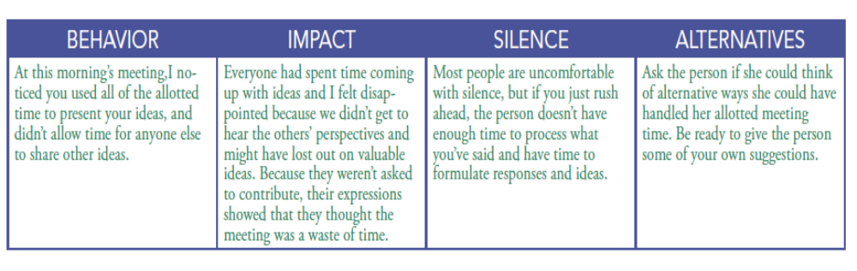
Start with the positive.
Positive feedback acknowledges good contributions and work well done. Give specific examples of what the receiver did well. Doing so is more meaningful than a general “Good job!” comment that can be said to anyone, any time, and doesn’t even have to be sincere. Let the receiver know the positive impact their contribution had on the department or organization so they understand the results – this also lets them know that you see it and appreciate it. In addition, reinforcing the positive encourages more of the same.

2.7 DOCUMENTS FOR PERFORMANCE REVIEW INTERVIEWS
Some of the documents required in a performance review interview are;
- Employee Goal Review and Planning: Supervisors may use the optional Employee Goal Review and Planning form to both review past performance and establish goals for the coming year. This form is not sent to Human Resources, but is a tool to be used by the manager and employee. It should be maintained by the supervisor. (See attached)
- Peer Assessment form may be used by a work group to provide each member with feedback. (See attached)
- Performance review form- this is the document which is used to record the results of the review interview. (See attached)
- Interview questionnaire: This contains the guiding questions for the interview.

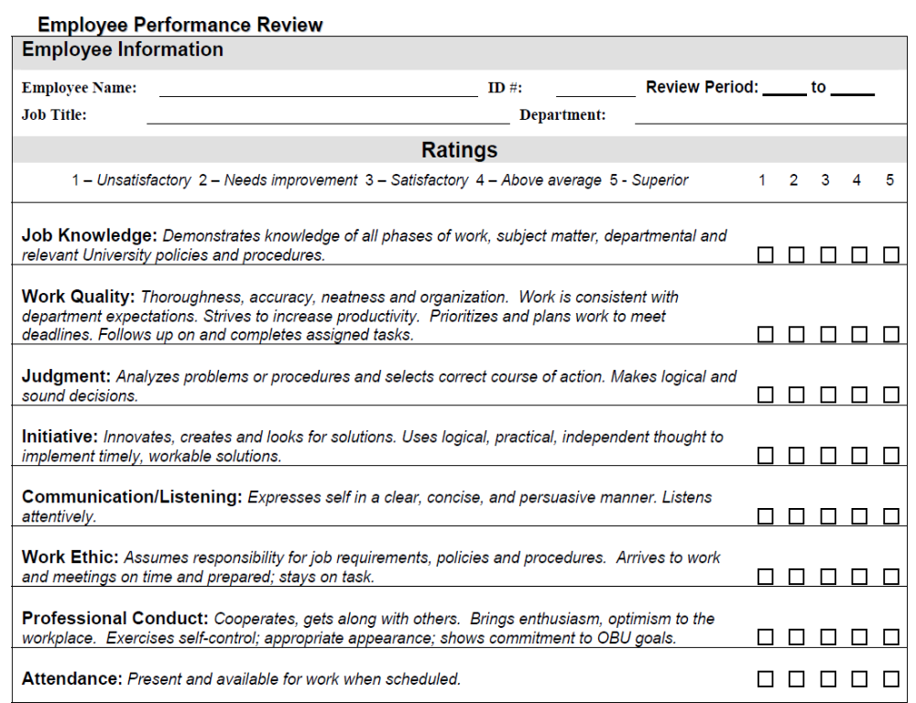

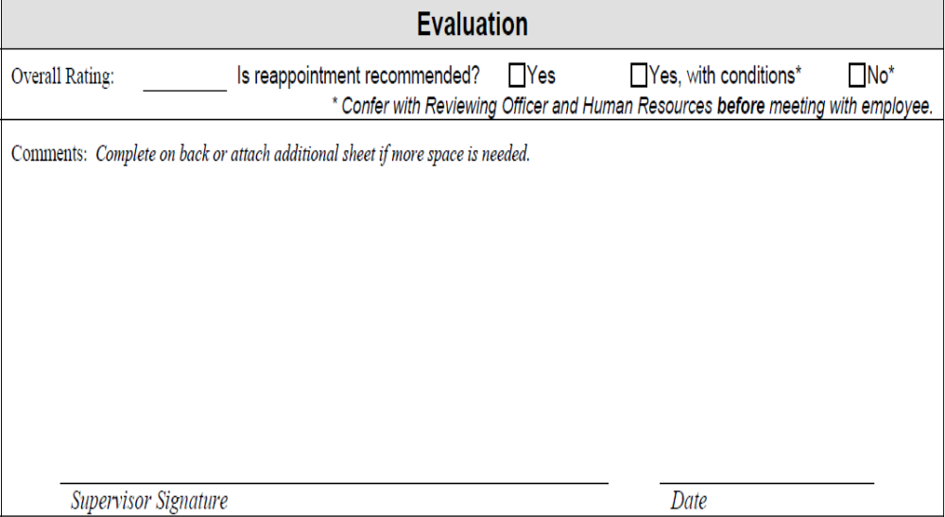

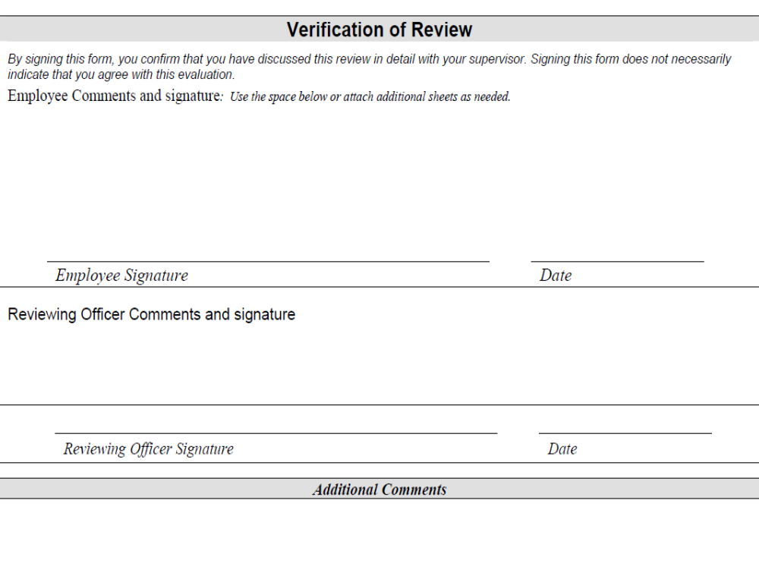

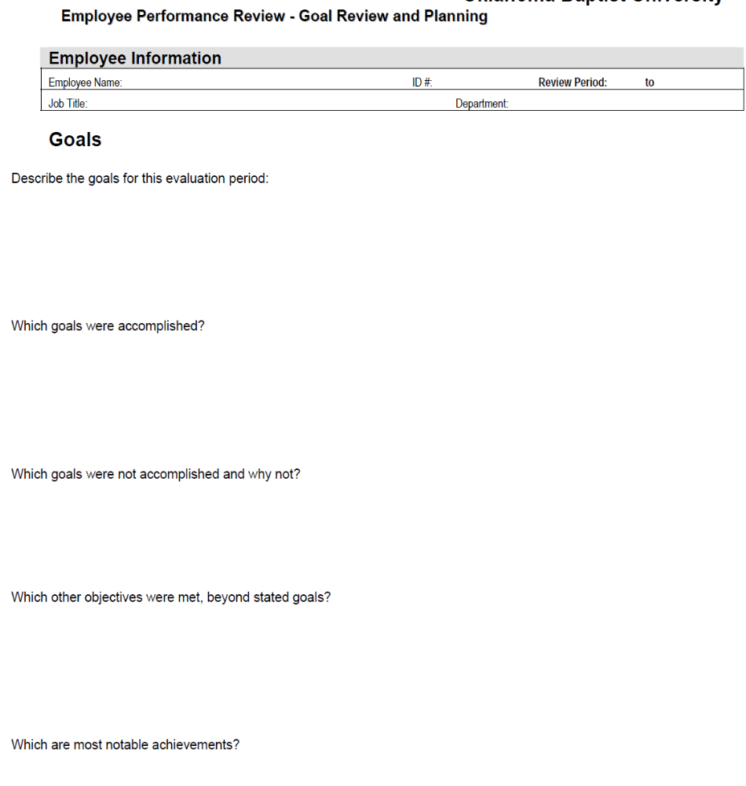

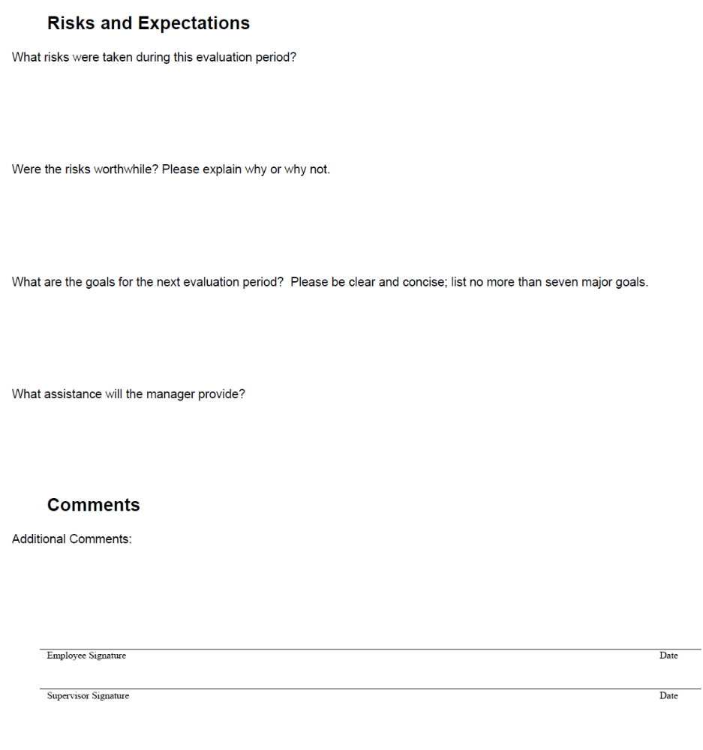

INTERVIEW QUESTIONNAIRE

STATUS – AGREEMENTS MADE AT THE LAST EPR
- Have the agreements in last year’s development plan been fulfilled? If not, why not?
- Which non-fulfilled agreements are still relevant, and how can you ensure they will be fulfilled next year?

WORK TASKS AND TASK PERFORMANCE
(Consult your task list)
- Which rewarding and less rewarding work tasks have you done over the past year?
- Which tasks did you do particularly well/less well? What was the reason?
- What initiatives have you taken in the course of the year? What results did they generate?
- Have you any preferences for other/new tasks in the near future?

WORKING CONDITIONS
- Do you enjoy your tasks and the division’s work approach?
- Which functional conditions are important for your job satisfaction? Are they in place today?
- Are there conditions that you want to change to achieve greater job satisfaction? If so, which?
- How do you experience the pressure of work and the demands made on you? Do you feel stressed?
- What are the reasons for the stress you may be feeling? How can your work situation be improved?
- Are there any circumstances or significant changes that are affecting, or may affect, your work situation in the month’s ahead (including changes in your personal life)?
- How would you describe your cooperation with your colleagues in the division and the organisation as a whole?
- Which work processes and routines can be improved? How?

EVALUATION OF COURSES AND TRAINING
(Consult your course list)
- What benefit have you gained from the courses/training you have taken part in this year?
- To what extent did the courses/training meet your expectations/needs/preferences?
- To what extent have you had tasks in which you could use what you learned from the courses/training?
- How have the completed courses/training affected your task performance?
- What changes in your tasks can increase the benefit of your competency development?

DIALOGUE ON SALARY (OPTIONAL)
- How do you assess your current salary relative to your performance?
- How does assess your chances of pay improvements this year?
- What are your expectations for pay improvements in the long term?
- What changes do you need to make to be recommended for pay improvements?

ASSESSMENT OF YOUR COMPETENCIES
- Which competencies do you need to develop over the coming year(s?)
- Which three specific competency development goals will you prioritise in the coming year?
- Which initiatives/activities can initiate the desired development?

LONG-TERM DEVELOPMENT
- Which special competencies/talents do you have that you would like to make more use of or develop?
- Which new tasks/challenges can ensure that these skills can be better brought into play?
- What competency development requirements would new tasks pose?
- What are your long-term development wishes?
- How does your supervisor assess your development options?
- What can you do to qualify yourself for this job profile?
- What is the first step on the road to achieving your development goals?
- Which initiatives will you personally take?

REFLECTION ;

A number of things need to be done in preparation to ensure a fruitful discussion:
- Review Appraisees' Performance Appraisal Forms to refresh your memory regarding the Performance Measures (Goals/Objectives/KPIs/Competencies) that were agreed with them.
- Review their previous Appraisal Summary & Performance Optimization Plans (POPs) to see what was agreed that they should work on improving. Did you do what you have undertaken?
- Study their Performance Record Notes as accumulated throughout the performance period. Consult all other relevant records on their performance.
- Inform them to prepare for the Appraisal by completing and printing out their Appraisal Prep Forms, and studying/printing out their Performance Record Notes. The system allows you to request that they release their Prep Form to you prior to the appraisal (check your company policy on this).
- Agree a mutually suitable date and time for the interview. A minimum of one week's notice should be given. For more senior and specialist positions, allow even more preparation time.
- Select a private, comfortable venue where you can meet in a relaxed, unhurried, informal atmosphere, without disturbances or interruptions. Avoid sitting behind a desk during the interview. Rather sit together with the Appraisee in front of your desk or, alternatively, at a conference table. Sitting behind a desk transmits a nonverbal message of formality, reinforcing the "superior-subordinate" relationship.
- Set aside adequate time for the Appraisal Interview, which may vary in length from 45 to 90 minutes, depending on the complexity and seniority of the position under consideration.

SECTION 3: CONDUCTING A PERFORMANCE REVIEW INTERVIEW

Specific Outcome

On completion of this section you will be able to conduct performance review interview.

Assessment Criteria

- The review is conducted in accordance with the arrangements previously agreed with the team member (SO 4, AC 1)
- Preliminary assessment of performance against the agreed standards is conducted using monitoring systems. (SO 3, AC 2)
- Findings on positive and negative aspects of the member's performance are recorded accurately, fairly and honestly for report back and follow-up. (SO 4, AC 3)
- An action plan to address performance gaps and build on positive performance is agreed upon with the employee.. (SO 4, AC 4)
- Agreed actions are documented and signed by both parties. (SO 4, AC 5)

3.1 INTRODUCTION
An appraisal interview is important because it helps improve an employee’s job performance by:
- Using this opportunity to communicate your appreciation for the employee’s contribution
- Informing the employee of his or her overall performance appraisal and the criteria used for determining the rating.
- Having an open proactive dialogue with the employee about how he or she can correct any performance weaknesses and build upon strengths.
- Clarifying any misunderstanding about performance expectations of the employee
- Building and cultivating a stronger working relationship between the supervisor and employee
- Establish goals and objectives for the coming year

3.2 CONDUCTING THE INTERVIEW
The type of employee, type of job and purpose of the interview varies widely, and as the interview is often a ‘problem-solving’ exercise, too much structure can be counterproductive. However, the following guidelines apply to most situations and may be helpful.
- Open by establishing rapport with the employee. Explain the purpose of the interview and what will take place. Some interviewers prepare a standard ‘opening script’.
- Emphasise that the interview is part of an ongoing and two-way feedback process.
- Discuss the job in general to begin with, and ensure there is agreement over its key tasks, content and responsibilities. Then focus on areas of agreement and strengths initially, moving gradually into areas of disagreement and performance weaknesses.
- Using specific actual examples, discuss instances of good performance, but avoid creating the situation where the employee expects criticism of other performance to immediately follow.
- Again using specific actual examples, discuss any aspects where performance needs to improve. Be specific and direct vagueness and talking around the problem are common faults.
- Focusing on actual job behaviour can help to control the emotional level of an interview. Employees may react unpredictably and strongly. While it is helpful to ‘get things out into the open’ in a constructive way, avoid linking behaviour to issues such as the employee’s personality — otherwise the interview may go out of control.
- If the employee appears to be quiet, and maybe nervous, ask him/her to comment on the way particular parts of the job are performed, or how specific incidents were handled. Provide plenty of opportunities for employees to raise their own issues and questions, and to suggest improvements to the job.
- Address all relevant matters during the interview. Nothing should be ‘left hanging’.
- Where disagreement occurs, typical reactions are ‘fight’ (to defend or argue back) or ‘flight’ (try to avoid the issue or pretend to agree). Both reactions must be resolved at the time if possible. In the case of ‘fight’, hear the employee out first, then acknowledge what was said and make notes of it, but then state or repeat that other issues were considered when making the assessment and provide evidence to support them. For ‘flight’, you may have to persist with more direct questions, to get to the bottom of the issue. Do not move on until you have.
- Where there are performance problems, explore the specific gap between current and required performance and discuss ways of closing it. Explain any potential consequences if this gap is not closed.
- Where a disagreement over ratings cannot be resolved in the interview, note that it occurred, but do not take the ‘flight’ approach by issuing an ‘average’ or ‘not applicable’ rating. Note down all points of disagreement and consider/discuss forms of follow-up action.
- Consider whether anything raised in the employee's self-appraisal sheds new light on your assessment, and be prepared to modify your appraisal if appropriate.
- If changes will be made to the appraisal, discuss those changes, and agree upon a date by which the final draft of the appraisal will be prepared and the appraisal will be signed.
- Discussion of the employee’s aspirations and ambitions should ensure that they are realistic, taking into account performance, ability, potential and opportunities within the organisation. If not, further discussion is needed and the outcome should be reflected in future goals and action/development plans.
Closing the interview
Finalise the interview in the following way:
- Summarise the key issues discussed and the forms of action agreed upon. Develop an action plan, ensuring the employee and any other party affected (such as trainers) receive copies.
- Set a timetable for review and follow-up.
- Some interviewers use a ‘closing script’ to ensure they cover everything.
- Complete any assessment tool used in the process, such as a rating form. Ask the employee to also sign this form once it is finalised, but if he/she does not, note that the invitation was made.
- Inform the employee that he or she can add or attach comments to the form. If the employee wants to do so, allow time to write them, and attach them to the original, signed file copy.
- Provide the employee with a copy of the completed form.
- Keep copies of appraisals on file. A recommended period is 3–5 years.
USEFUL TECHNIQUES TO FOLLOW WHEN DOING THE PERFORMANCE RATING
- Be factual and cite specific examples and accurate evidence of employee behaviour.
- Consider day-in, day-out performance over the rating period. Do not let one or two outstanding happenings influence your appraisal. Rate the employee and not the importance of the job or position. Personnel in “better” jobs are not necessarily better employees.
- Avoid the tendency to rate consistently high or low. Rate each employee honestly.
- Build on strength but do not avoid areas of needed improvement.
- The appraisal should be conducted by the individual’s immediate Manager /Supervisor with no one else present.
- The Manager / Supervisor and the employee must sign the form.
- Be familiar with any training opportunities available in your Practice

3.3 DEVELOPING AN ACTION PLAN
After agreeing on the performance ratings with the employee, the next stage is to develop action plans (or goals & objectives) to address performance gaps identified. Action plans must be developed in co-operation with the employee
- Choose goals that are as specific and practical as possible. Then compare them to what the employee has accomplished during the current appraisal period. Remember you are NOT DICTATING a plan of action. You are working with the employee to develop a viable plan, focusing on the most important goals instead of all the areas that need improvement.
- Set a timetable for reaching these goals and devise ways of measuring their achievements.
- As you develop the plan, be aware of problems that may require time to solve or are outside the employee’s control, for example, to improve performance and employee may need additional education, job experience, counselling, greater responsibility or even a new supervisor.
- Remember, scrutinise, judge, predict, counsel, help and train. These words sum up what performance appraisals is all about.
- By the time a performance appraisal process is over, we should be able to answer the two most important questions employees have about their work: HOW AM I DOING? and WHERE AM I GOING?
- We must know what employees have done in the past, how well they have done it, how we can expect them to perform in future and whether they are ready for a promotion/transfer
- Do not base appraisals on poorly recollected events, hearsay and personal likes. Apply a standard of measurement applicable to every employees work. Let employees review their written appraisal
The action plan is usually included in the performance appraisal rating form.

NOTE

An employee must be given the chance to read the results of the performance interview, and express disagreements.

The performance appraisal rating form must be signed by both the supervisor and the employee when agreements have been reached.

TEMPLATE: PERFORMANCE APPRAISAL RATING FORM

Employee: | Position No.
Title: | ❑ Annual
Department: | ❑ Orientation
Unit/ Division: | ❑ Interim

Employment Date: |  | Date of Job Change or Probation: |  | Evaluation Date:

Departments are required to establish a system of performance evaluations for staff employees that reflect an impartial rating of each staff member’s performance and potential for further advancement. Appraisals can be a positive means to assist the staff member in improving job performance.

Staff performance evaluations should be conducted on a periodic basis (at least annually) and should not reflect personal prejudice, bias, or favoritism on the part of the supervisor for the rating or review. It is important to be positive in all evaluation meetings. Remember performance is being measured, not the employee’s value as a person. Also, remember the employee must know what is expected in job performance and production in order to meet the expectations.

Form Instructions
- Both the employee and the supervisor should have a copy of the current job description.
- If you wish to have the employee participate in self-evaluation, provide a copy for the employee to use as a worksheet. Allow enough time for thoughtful review. Self-evaluation is helpful in stimulating discussion of ways in which supervisor and employee can work together to increase effectiveness.
- Use one of the following ratings to describe the performance of the individual in each of the categories.
(5) Performs Exceptionally Well: | Performance consistently exceeds expectations for the job.
(4) Performs Very Well: | Performance often exceeds expectations for the job
(3) Performs Well: | Performance consistently meets expectations for the job
(2) Needs Improvement: | Performance sometimes meets expectations for the job
(1) Unsatisfactory: | Performance does not meet expectations for the job.
- When giving a rating of 5 or 1, the Evaluator must provide an explanation for that rating in the comments section for that category. Use the back of the form or an additional page if necessary.
- All ratings in each category should be averaged together and listed in the comments section for that category. The final rating is the average of all category average ratings and may be reported as a number with two decimal places. Items that are not applicable (NA) should not be used to calculate the average rating for that category.
- Supervisor and employee must discuss the evaluation, progress made in performance, and progress toward objectives and goals for the coming year. Both the supervisor and employee must sign the form and both must have an opportunity to add comments.
- All ratings are reviewed and approved by the next-higher-level supervisor than the one who prepared the rating.
- The original form with the final ratings, comments and signatures is retained in the employee’s file in the department. The employee signs the form to acknowledge that s/he has seen the report and has been apprised of his/her evaluation.
- The employee has a right to make a written statement or rebuttal on the form at the time of the evaluation and/or within ten working days. If a statement is submitted within ten days, it will be attached to the evaluation report. Supervisors should make employees aware of this opportunity.
- A copy of the signed evaluation shall be provided to the employee within 30 days of the date of the evaluation or upon request.
factor ratings:
5 = Performs exceptionally well; 4 = Performs very well; 3 = Performs well; 2 = Needs improvement;
1 = Unsatisfactory; NA = Not Applicable
Any rating of 5 or 1 requires an explanation for that rating in the comments section
I. JOB KNOWLEDGE / TECHNICAL SKILLS | 5 | 4 | 3 | 2 | 1 | NA
a) Understands & performs assigned duties and job requirements
b) Uses techniques, materials, tools & equipment effectively
c) Follows procedures
d) Stays current with technology and job-related skills
e) Works in a safe manner
Comments Average Rating:

II. QUALITY / QUANTITY OF WORK | 5 | 4 | 3 | 2 | 1 | NA
a) Sets and adheres to priorities
b) Meets established productivity standards, deadlines and work
schedules
c) Uses resources efficiently and economically
d) Accomplishes accurate work with minimal assistance or supervision
e) Provides work products and services that consistently meet the needs
and expectations of both internal and external customers
Comments Average Rating:

III. INITIATIVE / JUDGMENT | 5 | 4 | 3 | 2 | 1 | NA
a) Takes effective action without being told
b) Analyzes problems and suggests effective solutions
c) Demonstrates willingness to learn new skills
d) Develops realistic plans to accomplish assignments
Comments Average Rating:

IV. DEPENDABILITY / SELF-MANAGEMENT | 5 | 4 | 3 | 2 | 1 | NA
a) Demonstrates punctuality and begins work as scheduled
b) Contacts supervisor concerning absences on a timely basis
c) Can be depended upon to be available for work
d) Manages own time effectively
e) Accepts responsibility for own actions and ensuing results
f) Demonstrates commitment to service
Comments Average Rating:

V. COMMUNICATION / TEAMWORK | 5 | 4 | 3 | 2 | 1 | NA
a) Understands the organization’s policies, procedures, goals and purpose
as required for the job
b) Promotes and demonstrates trust, mutual respect and a cooperative
work environment
c) Conveys work-related information and ideas to others in oral and/or
written communications effectively
d) Offers assistance, is courteous and works well with customers and
fellow workers
e) Supports cultural diversity in the workplace
Comments Average Rating:

VI. INNOVATION / CHANGE | 5 | 4 | 3 | 2 | 1 | NA
a) Is receptive to new ideas
b) Adapts to new situations and changes in the work environment
c) Identifies opportunities to improve work processes
d) Demonstrates creativity and contributes new ideas
Comments Average Rating:

ADDITIONAL JOB FUNCTION SPECIFIC TO POSITION (OPTIONAL)
 | 5 | 4 | 3 | 2 | 1
Comments Average Rating:

Overall Rating:

GOALS: (optional)
Review progress toward goals and staff development achievements established for this evaluation period. Be sure to include any additional goals established during the course of the rating period. Discuss not only strengths and/or significant accomplishments but also difficulties, possible causes and recommended actions.

OBJECTIVES: (optional)
Supervisor and employee discussion of future objectives is essential. List specific position goals and staff development opportunities to work toward during the next evaluation period. Include time frames, criteria for completion, and planned supervisor actions to assist. Your supervisor must approve future objectives.

STATEMENTS: If the employee disagrees with the rating, the employee and supervisor narrative statements should explain.
Supervisor (Optional)
Employee (Optional)
Department Head (if overall rating is changed)
SIGNATURS:
I acknowledge that I have reviewed this report with my supervisor and have been apprised of my evaluation. I understand that I may make a written statement on this form now or within ten working days. If a statement is submitted within ten days, it will be attached to this evaluation report.
Employee: Date:
Supervisor: Date:
Date of Supervisor’s last appraisal training:
Supervisor or Dept. Head: Date:

Employee must receive a signed copy of this evaluation within 30 days or upon request

ROLEPLAY ACTIVITIES
You are required to role-play the following scenarios. In the presence of observers prepare and conduct a performance appraisal interview.

Role-players
- Supervisor
- Employee

Supervisors Guide

INSTRUCTIONS:
As a supervisor, what questions do you need to ask and answer to prepare for your appraisal?
Write the questions and their answers below.
1.
2.
3.
4

Scenario 1
You are the supervisor of Joe, a personal banker at your branch office of First Bank. Joe is excellent with elderly customers and small-business owners. They ask for him when they come in and are willing to wait until he is available. His cross-sell ratio for current customers exceeds the goal of 2.95. His cross-sell ratio for new customers falls short of the goal of 2.10. Joe volunteers to help with special projects, especially loan projects. However, he resents working Saturdays and only does so when asked. Joe eventually wants to be a branch manager. Joe is also punctual and has a satisfactory attendance record.

Scenario 2
You are the supervisor of Sally, who has been your secretary for the past six months. She accurately completes the work you give her, often finishing before the deadline. As a result of being an efficient worker, she usually has spare time on her hands. The problem is that she spends that time unproductively.

Scenario 3
You are the supervisor of Tom, who is one of your bakery delivery drivers. Tom is a very safe driver and during the past year had has no accidents or tickets. Tom averages 17 deliveries per day while the rest of your drivers average 23. Tom has a very good relationship with his customers because he will take time to listen to them.

Observer’s Guide
INSTRUCTIONS: As an observer, your role is to observe the other participants during the skill practice and record your observations. After the skill practice, you should be prepared to discuss your observations with the supervisors.
- Was the supervisor prepared?
- Did the supervisor start the appraisal with a warm-up?
- Did the supervisor ask the employee for his or her opinion of his or her performance?
- When the supervisor assessed the employee’s performance, did he or she use specific examples?
- Did the supervisor offer suggestions to help the employee?
- Did the supervisor explain the consequences of improving/not improving performance to the employee?
- Did the supervisor solicit self-development goals from the employee?

